Study Packet for the June 2018 Geometry Regents Common Core
Here’s the deal. You’re going to pass the Geometry Regents. I believe that through this guide and the preparation you have had up to this point, you will be ready. In this packet we will cover some basic topics that come up on every Geometry common core regent. If you can master these topics you have a good chance at passing the regent.
Here’s the plan:
Day | Do this
Monday 6/11 | Pages 2-5
Tuesday 6/12 | Pages 6-10
Wednesday 6/13 | Pages 11-14
Thursday 6/14 | Do the worksheet on Directed Line Segments (Partition Point) uploaded to Ms. Pellei’s page at foresthillshs.org.
Friday 6/15  Saturday 6/16  Sunday 6/17 | Completely rest one of these days, unless you are attending Geometry Regents Review on Saturday and Sunday from 9 – 12; then only do that and rest the remainder of the day.  On the other days, do the “Everything in Geometry” document uploaded to Ms. Pellei’s page at foresthillshs.org. This may take you two days but, as it ties much of the entire curriculum together in a single extended problem, it is worth the time spent.
Monday 6/18 | The June 2015 Geometry Common Core regents. You can find a video of Mr. Estrada, Math for America Master Teacher, doing this here: https://youtu.be/dDwDcg9SPIM
Tuesday 6/19 | Test is scheduled to start at 8:30am. Be at FHHS by 7:45.
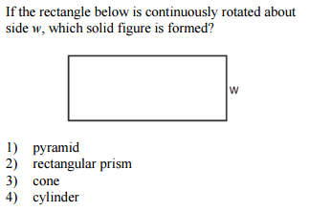
Guidance: This almost always comes up. You can always sketch out the situation to visualize the resulting solid. However, these types of questions essentially boil down to these three things:
Revolving 2-D figure to get 3-D figure
Rectangle around a line Cylinder
Right triangle around a line Cone
Half Circle around a line Sphere

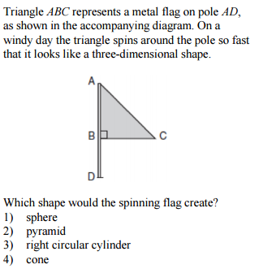
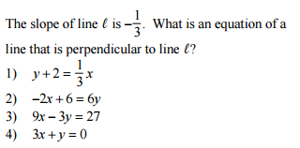
Guidance: If you want to pass this test then you better know that
1. The slopes of parallel lines are equal
2. The slopes of perpendicular lines are negative reciprocals eg :$\frac{a}{b} and-\frac{b}{a}$
Put each of the choices in y=mx+b form and select the one that has a slope that is the negative reciprocal of -1/3

If you want to be successful in this test, you need to know these properties. Memorize this and practice their application in the questions that follow.
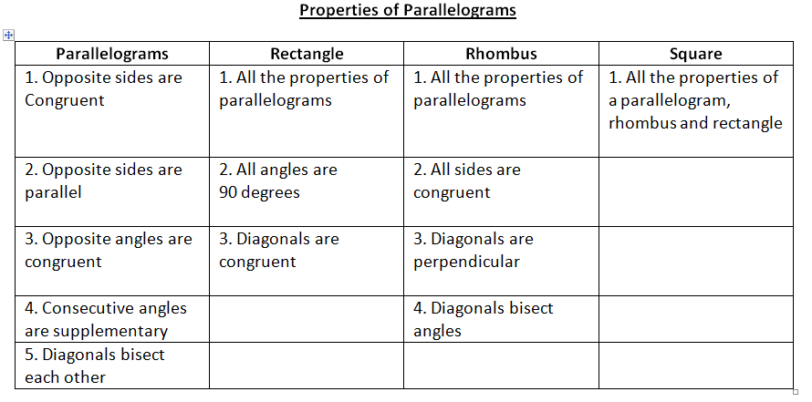
Recall: Every member of a subset is a member of the larger set, e.g. all squares are rectangles, rhombuses, parallelograms, non-special trapezoids, and quadrilaterals. Memorize the family tree on page 3 of the formula sheet!
Multiple Choice Questions:

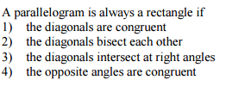
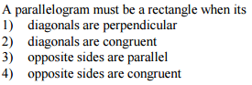

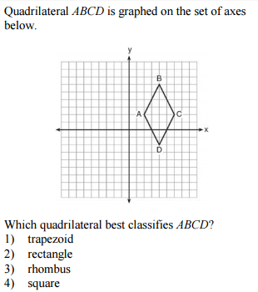
Guidance: I think the answer is obvious here via process of elimination. However, we are supposed to analyze the slopes of the diagonals and the sides (Especially if this were a Part II, III or IV question). In this case the slopes of the diagonals are
Slope of AC = 0 and
slope of BD=Undefined which makes the diagonals perpendicular

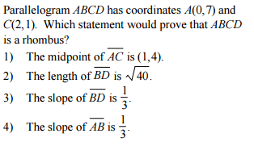
Guidance: Remember, the diagonals of a rhombus are negative reciprocals. AC is a diagonal. What is the slope of AC?
Slope of AC=
Since we want to prove it’s a rhombus then we need the slope of the other diagonal to be what?

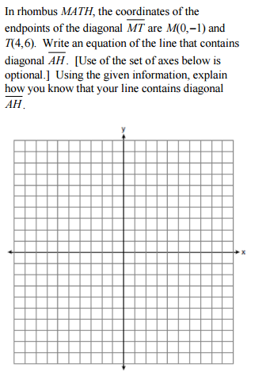
Guidance: Use the provided axes to graph MT.
Slope of MT =
Given that MATH is a rhombus, what must be the slope of the other diagonal?
Slope of AH =

Now we need to write the equation of the line. Substitute below and solve for b. (Hint: (X,Y) come from the midpoint of the diagonal)
x= y= m= b=?
y = m x + b
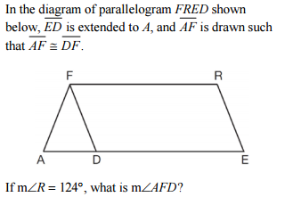

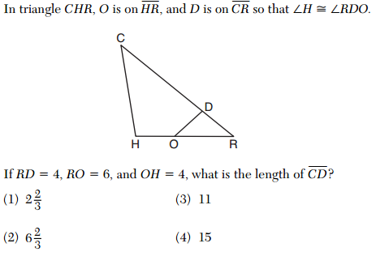
Guidance: Label the given congruent angles and sides. Separate the triangles: rotate RDO so that R is above, D is lower left and O is lower right. Write a proportion and solve.

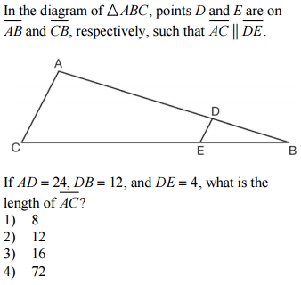
This is technically SAS for congruent triangles but it still works for similarity.
Guidance: Label the given sides. Separate the triangles. Write a proportion and solve.
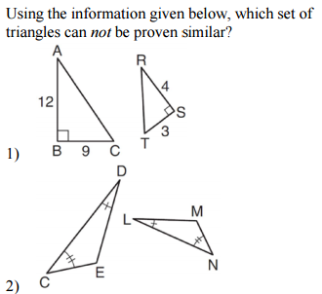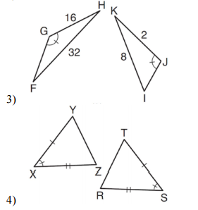
This is AA for similarity
and can be used to prove similar triangles
This is SAS for similarity
and can be used to prove similar triangles
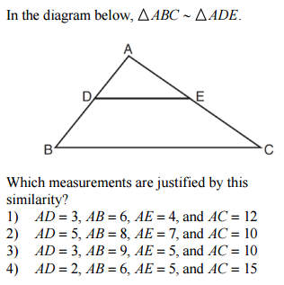
Guidance: We can justify similarity by demonstrating that the sides are proportional and the angles in between those sides are congruent. Which choice gives us proportional sides For example:
Choice 1: $\frac{3}{6}=\frac{4}{12}$
Cross multiplying will give us 24=36 which is not true. Therefore, those sides are not proportional. Choice 1 is not the answer.

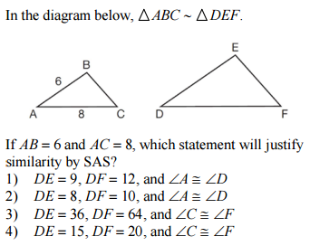
Guidance: We can justify similarity by demonstrating that the sides are proportional and the angles in between those sides are congruent. You’ll have to work out each choice.

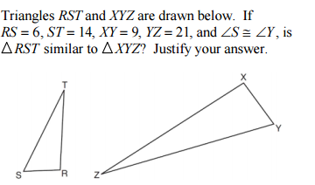

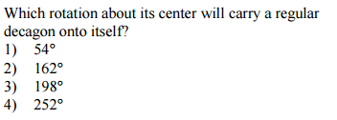
Guidance: Pretty straight forward question about rotating a polygon onto itself. Here is the formula to get the minimum amount of degrees you must rotate so that it maps onto itself:
$$\frac{360}{n}$$
Once you calculate 360/n, any multiple of this number will be the correct choice.

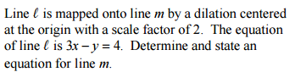
Guidance: Put the equation in
y=mx + b form. We only multiply the “b” by the scale factor when dilation the equation of the line centered at the origin

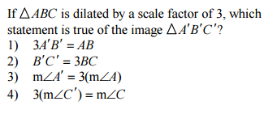
Guidance: Dilations preserve the angle measurements; only the sides will change.
It’s helpful to translate the choices to English like below:
Choice1: AB is 3 times larger than A’B”
Choice2: B’C’ is 3 times larger than BC
Choice3: Angle A’ is 3 times larger than Angle A
Choice 4: Angle C is 3 times larger than C’

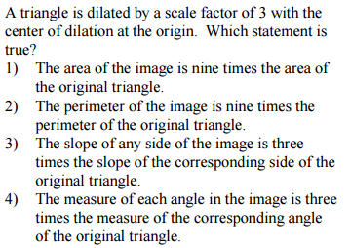
Guidance: When a figure is dilated we can say the following about the ratios
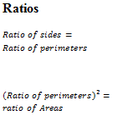

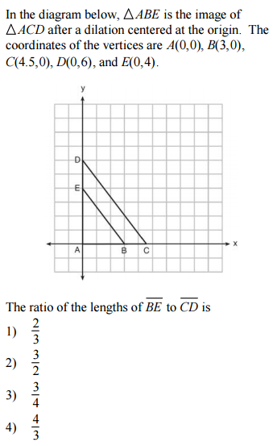
Guidance: The ratio of BE:CD is the same as the ratio of AB:AC. Because the center of dilation is Point A.
AB=
AC=
The ratio of AB:CD =
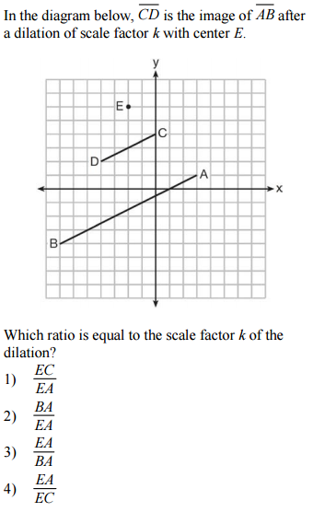
Guidance: Go back to the previous problem. How does the work in the previous problem apply here? I’ll give you some examples
We can say
$$\frac{DC}{BA} or \frac{ED}{EB}$$
Are equal to the scale factor k. However, since these are not in the answer choices; that must mean there is another ratio we can write. I’ll leave that one to you.
Guidance: You know the deal here. Label the hypotenuse, opposite and adjacent with respect to the reference angle. Use the appropriate trig. Ratio.
SOH CAH TOA
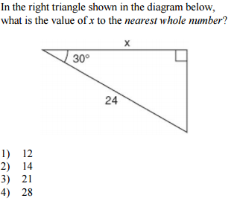
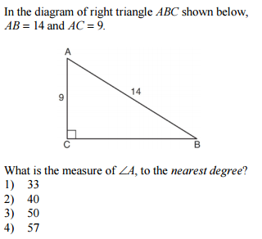
Guidance: Remember that with co-functions (Co-sine and sine) the left side equals the right side when the angles add up to 90 (Complementary)
Examples: Sine(30)=Cos(60);
Cos(15)=Sine(75)
Guidance: You know the deal here (Yeah I copied and pasted that from before). Label the hypotenuse, opposite and adjacent with respect to the reference angle. Use the appropriate trig. Ratio. The difference here is that you need to use inverse sine or inverse cosine or inverse tan to get the angle.
SOH CAH TOA
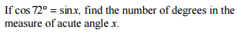

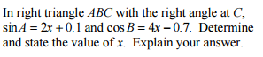
Guidance: This looks tricky but it’s essentially testing the same concept as the previous question. Therefore, we can write the following equation to solve for x.
2x+.1 + 4x-.7 = 90

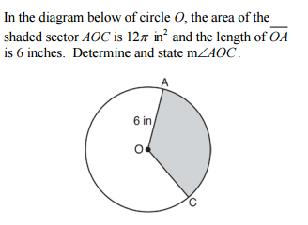
Guidance: This is a sector of a circle problem. For this problem you need to know how to find the area of a circle $(A=πr^{2})$ and work with the formula below:
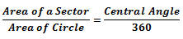

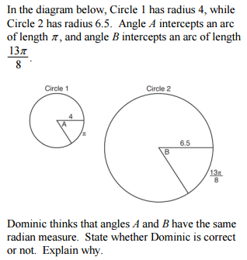
Guidance: This is an arc length of a circle problem. For this problem you need to know how to find the circumference of a circle $(C=2πr)$ and work with the formula below:
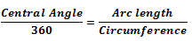
In this problem the central angle is unknown.

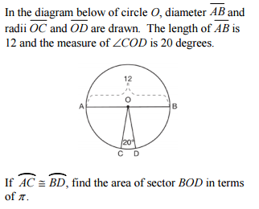
Guidance: This is a nice variation of the sector of a circle problem. The trick here is realizing that Angle BOD, Angle DOC and angle COA add up to 180 and solving for angle BOD. Then use the formula below

Find the Volume of the figure below to the nearest tenth:
Guidance: You’ll definitely see Volume questions and they are rarely straightforward. For this object we need to find the volume of the hemisphere the top and the volume of the cone. Then we add up the results.
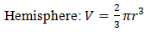
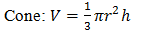

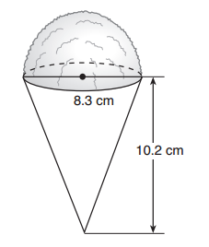
Guidance: Find the volume of the cylinder and then divide by 231 to get the amount of gallons in a barrel of fuel oil.

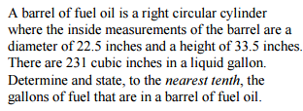

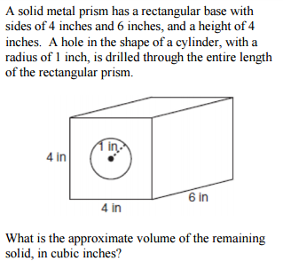
Guidance: The word “remaining” at the end hints that we need to subtract two quantities.
First find the volume of the rectangular prism and then find the volume of the cylinder. Subtract these quantities and you have the answer.
V of prism = (Length)(Width)(Height)

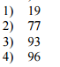
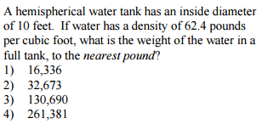
Guidance: You can bet your life savings that density will be on this test. For this question you need to find the volume of the hemisphere first and then plug in to the formula below to get the weight. Also, in the formula below Total Weight is Mass.
$$Total Weight=Density*Volume$$

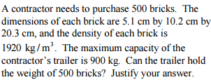
Guidance: First, did you realize the density is in KG per Meters³? That means we need to convert everything to meters first. After that, find the volume of 1 brick in METERS.
V=(Length)(Width)(Height)
2) Find the volume of 500 bricks. Just multiply what you got by 500
$$3) Total Weight=Density*Volume$$
$$\frac{Total Weight}{Volume}=Density$$

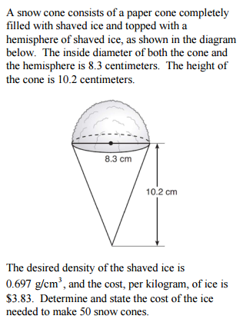
Guidance: First, did you notice the density is in grams per centimeters and the cost is in kilograms? That means we need to do a conversion at some point.
1) Find the weight of one cone
$$Total Weight=Density*Volume$$
2) Convert the weight to kilograms by dividing by 1000
3) Multiply by 50 since we want the weight for 50 cones.
4) How much for 50 cones if the cost is $3.83 per KG. You’ll need to multiply 3.83 by the weight of 50 cones.
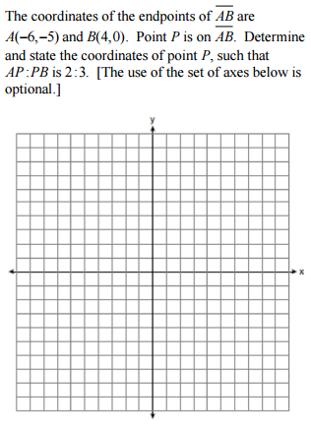
Guidance: 1) Plot the given coordinates of A and B.
2) Divide up the line segment into five equal parts (2:3 ratio means we need 5 equal parts (a + b = 2+3)
3) Find the point that divides the segment into a 2:3 ratio
$$x_{P}= x_{1}+ \frac{a}{a+b} \left(x_{2}- x_{1}\right)$$
$$y_{P}=y_{1}+ \frac{a}{a+b} (y_{2}- y_{1})$$

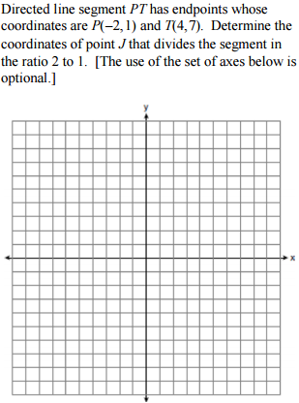
Guidance: It’s important that you use the graph for these questions if you need it. It gives you a good visual.
The process is straightforward, same as the previous question. This time though, divide up the line segment into 3 parts since it’s a 2:1 ratio.

What is the center and radius of the circle with the following
Guidance: The trick here is to switch the signs of -1 and -2 to get the coordinates of the center.
To get the radius take the square root of 25
Equation, already in standard form? $(x-1)^{2}+(y-2)^{2}=25$

Center coordinates are ____________ and
the radius is ___________.

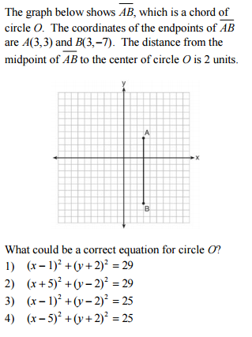
Guidance: The center of the circle is the midpoint of the diameter. Find the center. (There are two possibilities, sketch them out)

The radius of the circle is the distance from the center to either point A or B.
Write the equation of the circle in this form:
$$(x-h)^{2}+(y-{k)}^{2}=r^{2}$$
(h,k) Center of the circle
rRadius of the circle
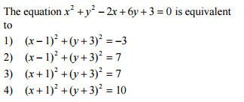
Guidance: Use completing the square to rewrite the equation in standard form. Move all the constants to the right side and write this:
$$x^{2}-2x+ +y^{2}+6y+ =-3+ +$$

